Creating Tables:

PRACTICAL-2

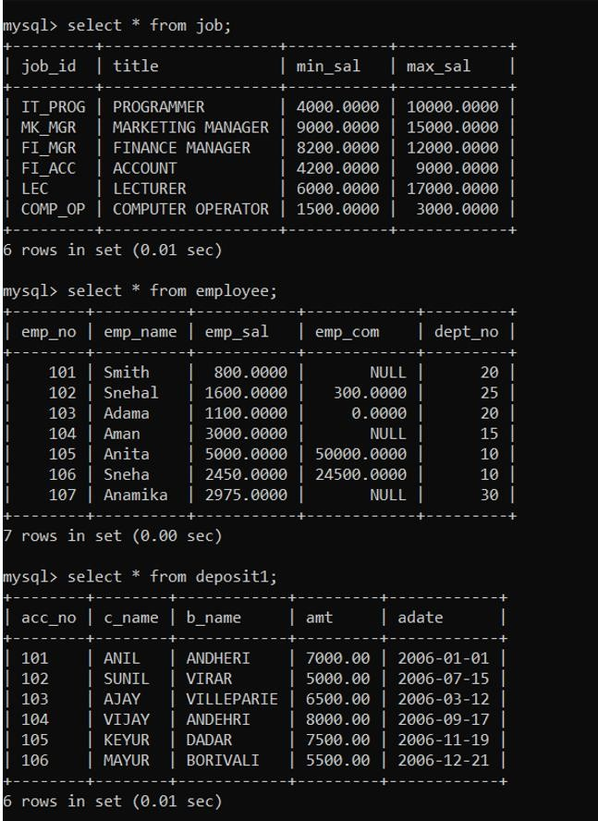

1. To create table Job:



1. To create table Employees:



1. To create table Deposit2: Inserting Data into Tables:



1. Insert Data in Job:



1. Insert Data in Employees:



1. Insert Data in Deposit2: Queries to be performed:



1. Retrieve all data from employees, job and deposit2. Output:

EMPLOYEES:

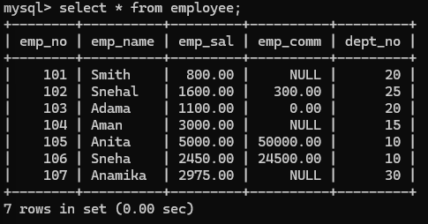

JOB:

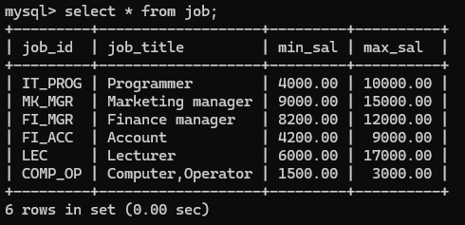

DEPOSIT2:

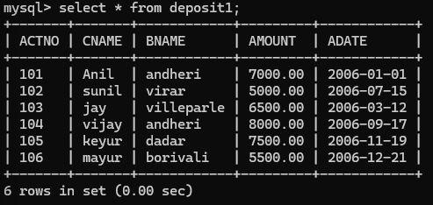

1. Give details of account no. and deposited rupees of customers having account opened between dates 01-01-06 and 25-07-06. Output:

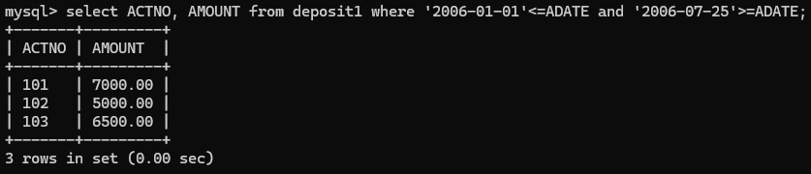

1. Display all jobs with minimum salary is greater than 4000. Output:

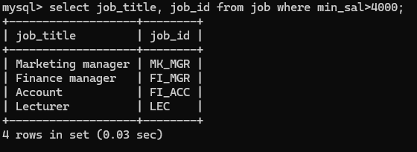

1. Display name and salary of employee whose department no is 20. Give alias name to name of employee. Output:

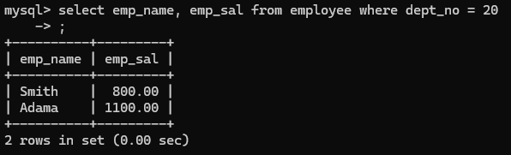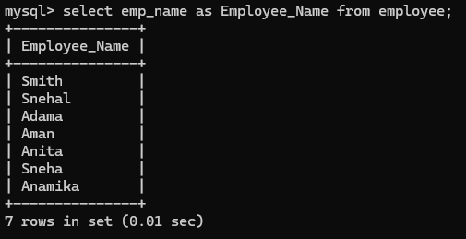

1. Display employee no, name and department details of those employee whose department lies in (10, 20). Output: To study various options of LIKE predicate:

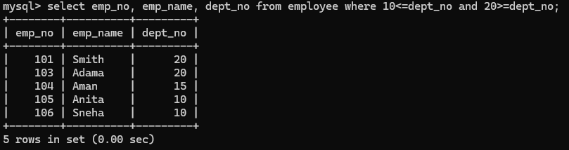

1. Display all employee whose name start with ‘A’ and third character is ‘A’. Output:

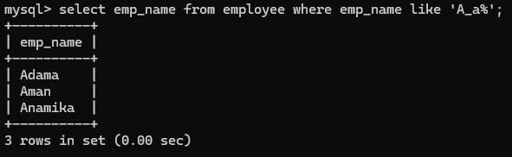

1. Display name, number and salary of those employees whose name

is 5 characters long and first three characters are ‘ANI’. Output:

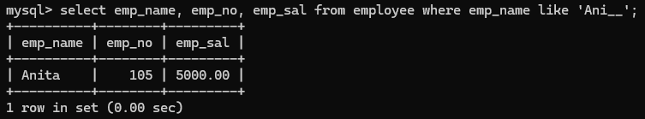

1. Display the non-null values of employees and also employee name second character should be ‘N’ and string should be 5 character long. Output:

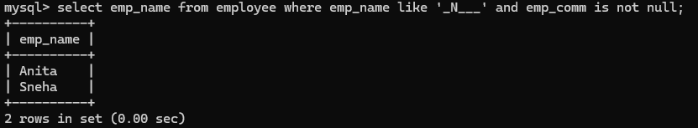

1. Display the null values of employee and also employee name’s third character should be ‘A’. Output:

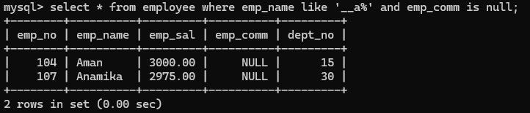

1. What will be output if you are giving LIKE predicate as ‘%\_%’ ESCAPE ‘\\’ Output:

